North South University



**CSE299:** Junior Design Course

Final Project Report on Design & Development of AGB (Adorsho Gram Binirman)

**Faculty Initial:** ITN

**Semester:** Summer’19

**Section:** 12

**Group:** 04

**Submitted By**

M Saydur Rahman (1520490642)

Anwar Shadaab (1611383042)

**List of Contents**

|  |  |
| --- | --- |
| Content | Page No. |
| Abstract | 3 |
| Introduction | 3 |
| Background Information | 4 |
| List of Components | 4 |
| Contributions | 4, 5 |
| Gantt Chart | 5 |
| Sample Screenshots | 6, 7, 8 |
| ER Diagram | 8 |
| Conclusion & Future Implementation | 9 |
| References | 9 |

ABSTRACT:

We create a website for social welfare and by this website people are likely to join social development. These days most people will go through under tech mobilization by this. So we develop a website for a rural area ,by this people can get all information and concern about the development and it is a rural development program which include social development, cultural development and spread motivation among the people of social mobilization in the village and most important AGB also bring all the political party working under a same umbrella while taking the responsibility and improve physical and infrastructural development of a village and turn into a model village under this scheme every member of parliament choose a rural area each from the constituency they represent except their own area fixed a parameter and make the area as model village by 2023.

INTRODUCTION:

AGB is a rural development program which include social development, cultural development and spread motivation among the people of social mobilization in the village. AGB also bring all the political party working under a same umbrella while taking the responsibility and improve physical and infrastructural development of a village and turn into a model village under this scheme every member of parliament choose a rural area each from the constituency they represent except their own area fixed a parameter and make the area as model village by 2023.

The website that we have made has some sections in it. First, it has an index or dashboard page where there is two links – Members of Parliament & List of Areas/Seats. Clicking on those links will redirect one to two separate pages where the lists of MP’s & list of Areas are stored and showed. The attributes that will be shown on MP’s list page are Seat, Name & Area. The attributes that will be shown on Area’s list page are Name, Seat No. Only admins can add MP’s and Areas in the list through an Admin Panel. Viewers can only view the list.

There are also three other sections – Complaint, Action against Complaint & Current Projects. Any viewers can use complaint box regarding any problem related to this webpage faced by them. The complaints will be stored into database. Action against Complaint & Current Projects will be shown on separate pages and it will be written by Admins only. There is Sign Up system for viewers.

The admin panel is consisted of four sections – Manage Current Project, Manage Action against Complaint, Manage MP & Manage Area. Here admins can add new MP, Area/Seats and also can add current ongoing projects and the actions that has taken against a complaint and all will be shown on their respective pages.

BACKGROUND INFORMATION:

Probably in Bangladesh, this concept has never been used to make websites or application. But in India, some of students of CSE in Sagar Institution made an android application – Sansad Adarsh Gram Yojana. So we get the idea from their video which was uploaded on YouTube. Through this Application User can see the activity which are happened in villages, see the information regarding adopted villages, get the notification regarding SAGY and also can do the complaints regarding the SAGY activities. We didn’t find any other website or app that shows the same concept as this. We adopted the same concept but some changes were made as SAGY has two separate sections like ‘notifications’ & ‘recent activity’ but we have constructed ‘current project’ section instead of two pages. Also they have made an android app whereas we made it as a webpage.

LIST OF COMPONENTS:

My groupmate & I tried to make the same webpage but with different components. So the list of components that my groupmate & I used are given unitedly-

* **Client on Internet:** Google Chrome, Windows 10
* **Web Server:** Apache
* **Database:** MySQL (phpMyAdmin)
* **Markup Language:** HTML, CSS, Bootstrap
* **Scripting Language:** PHP, Laravel
* **Text-Editor:** Visual Studio Code, Sublime Text Editor 3

CONTRIBUTIONS

As my groupmate & I have worked with different components so entire section of this project were done by both. Entire section in a sense, we both have made dashboard, complaint box, current projects, action against complaint, list of MP’s & list of area/seat. The front-end of this project was made with the help of Bootstrap & an admin panel as well. Saydur Rahman have used WAMP, HTML only, PHP for back-end, Sublime Text Editor for coding. I used XAMPP, HTML, CSS, Bootstrap Framework, Laravel framework of PHP, VSCode for coding. The contribution of project is given in the next page.

|  |  |
| --- | --- |
| Name | Contribution |
| Anwar Shadaab | * Front-End of main webpage & Admin Panel page using HTML, CSS & Bootstrap * Back-End of list of MP’s, List of Seat/Area, Admin Panel, Complaint Box, Action against Complaints, Current Projects |
| Saydur Rahman Sami | * Front of main webpage using HTML * Back-End of list of MP’s, List of Seat/Area, Complaint Box, Current Projects, Action Against Complaint |

GANTT CHART

SAMPLE SCREENSHOTS

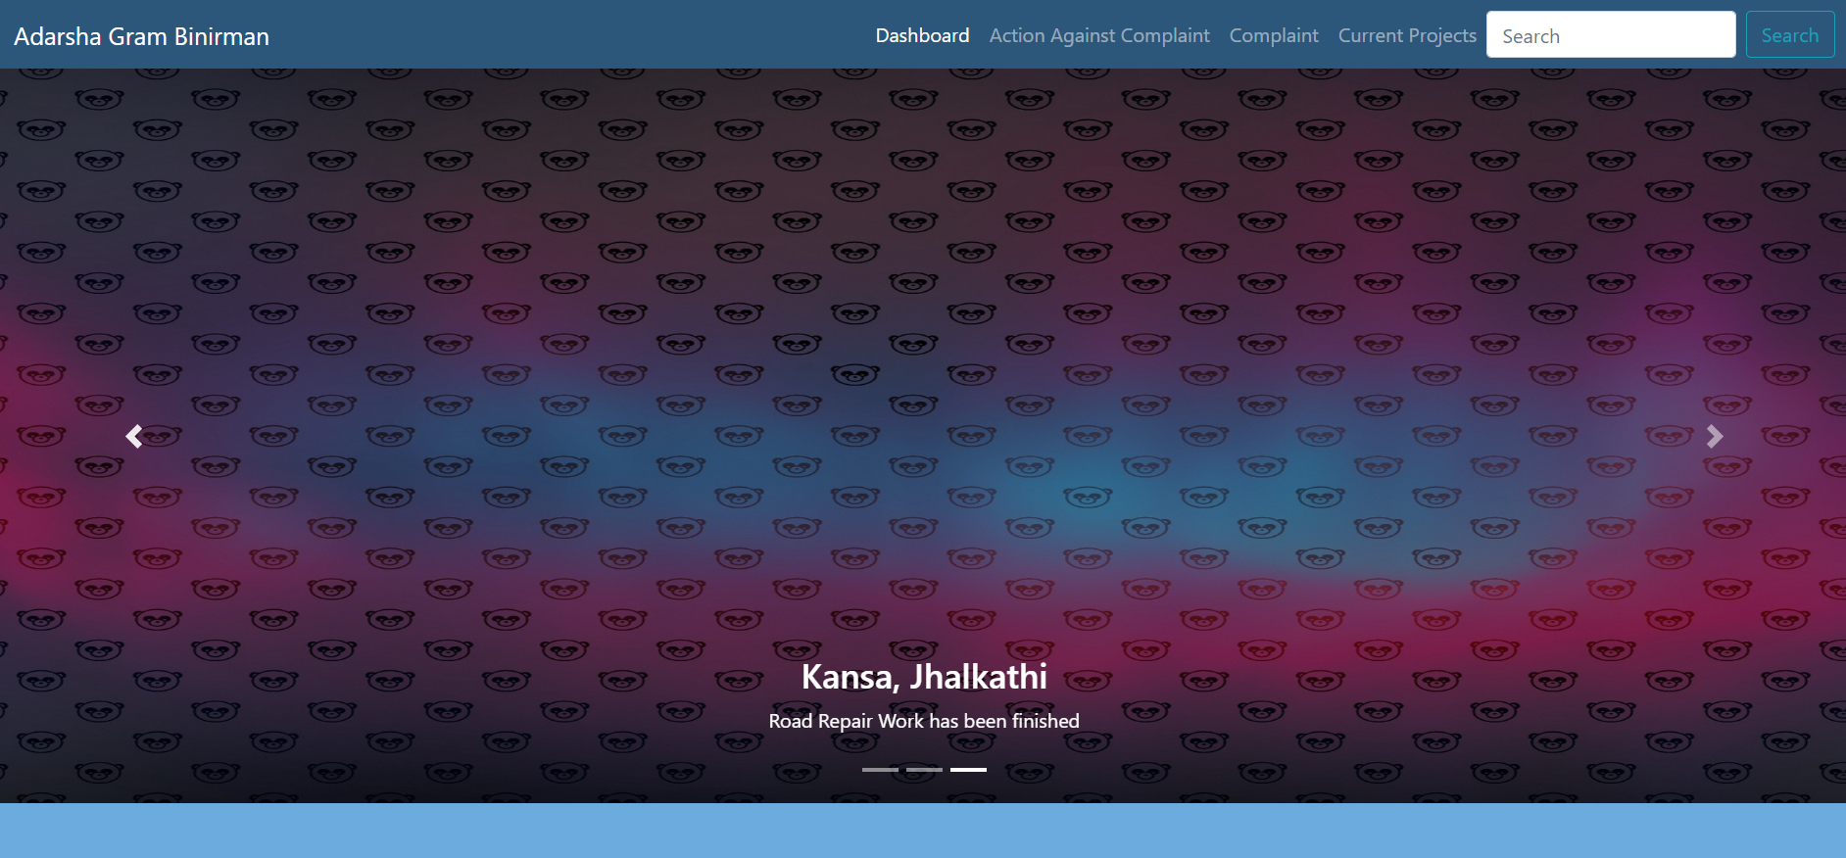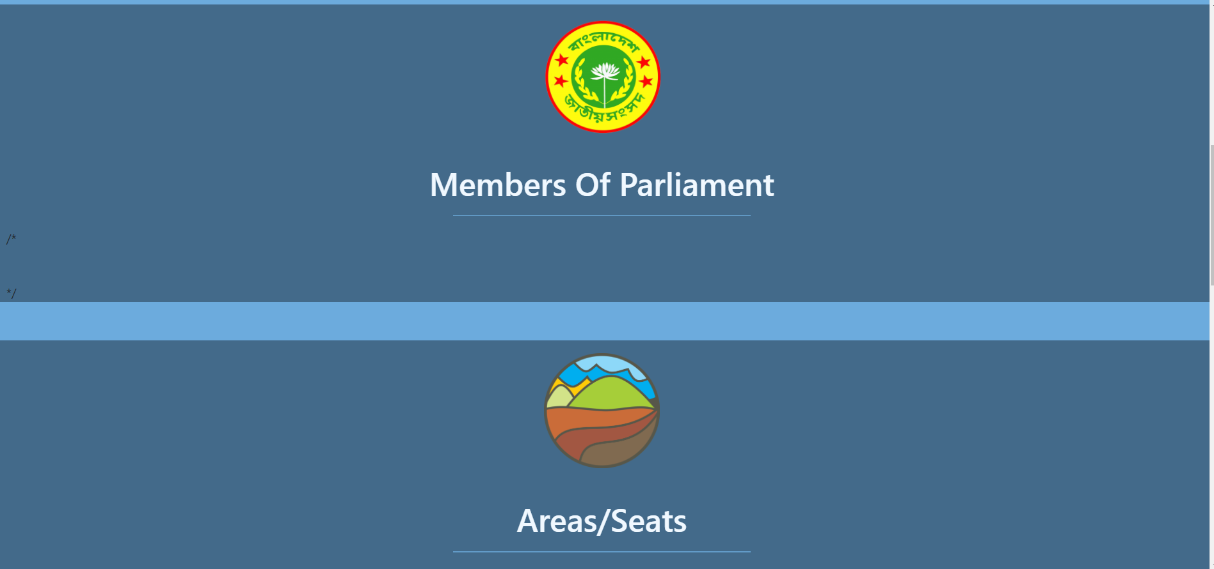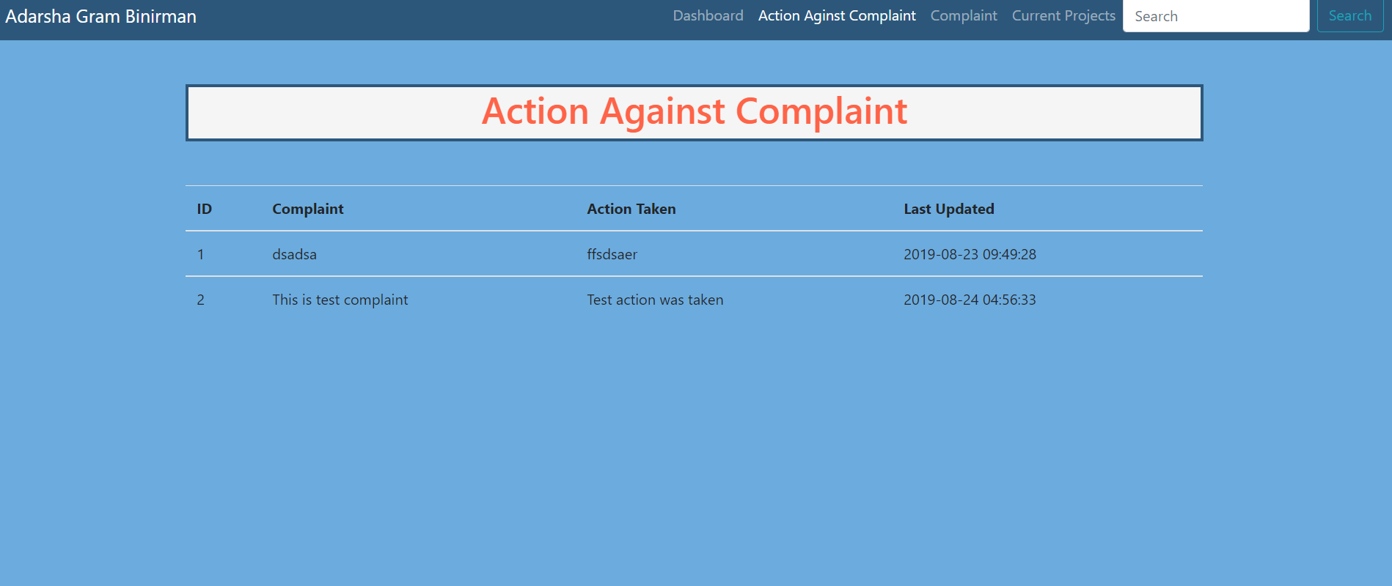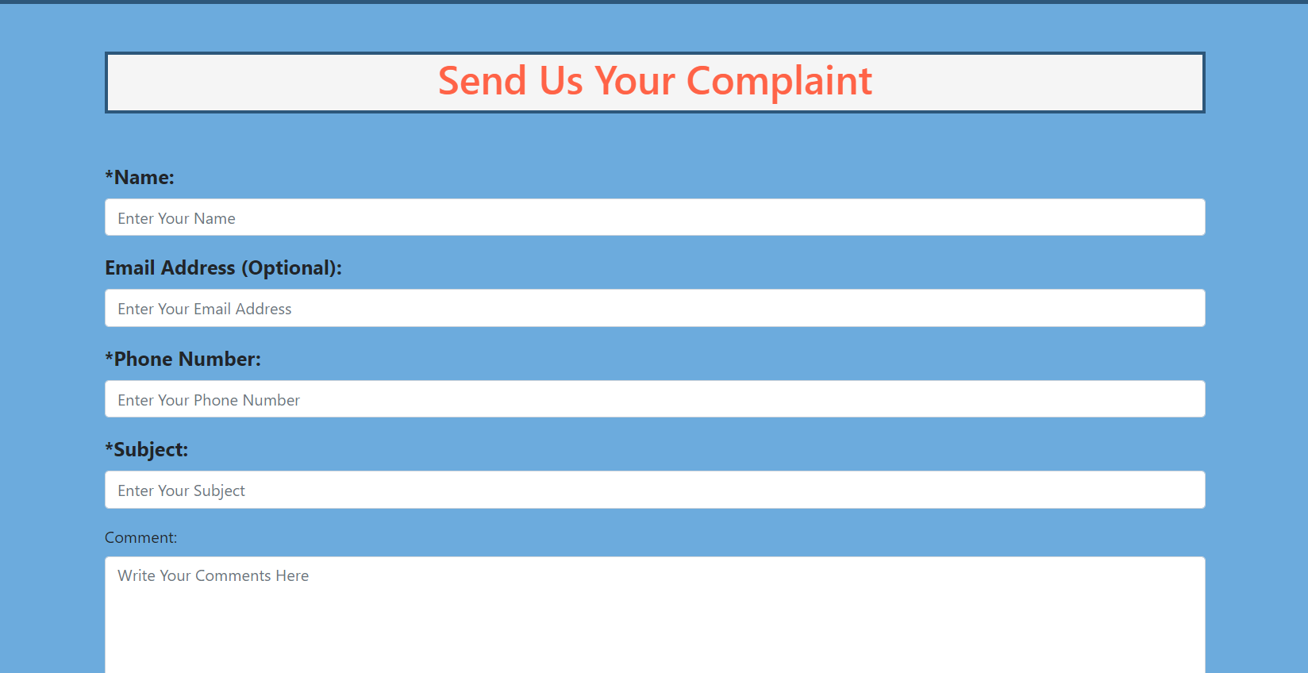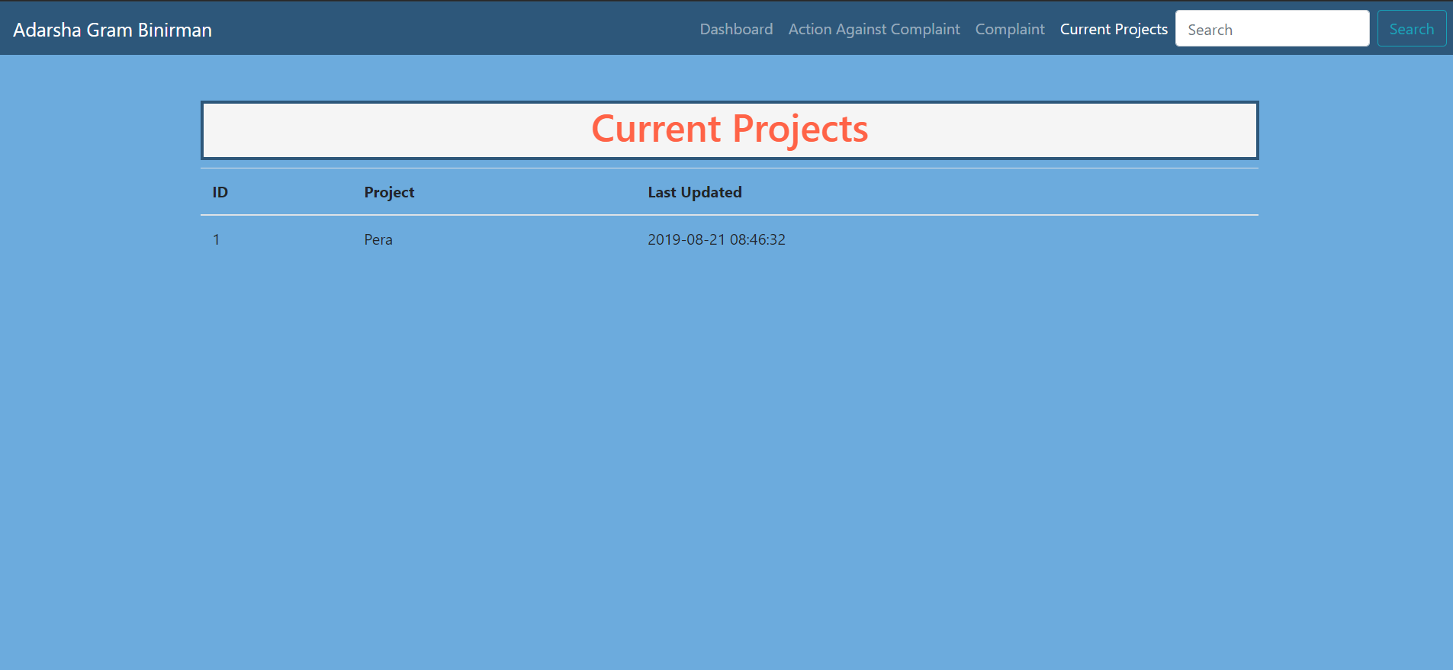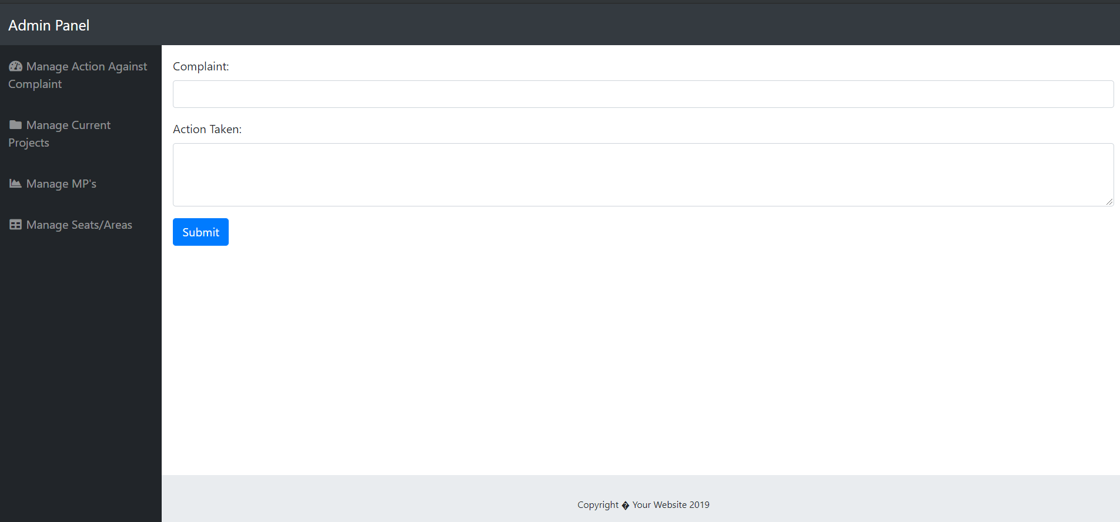

ER DIAGRAM

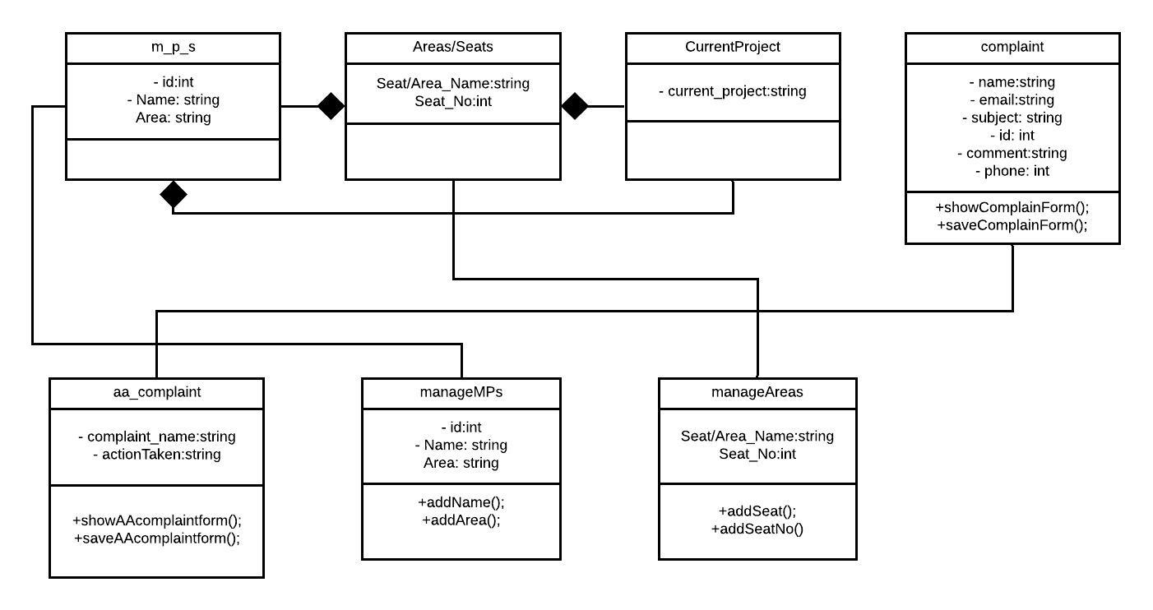

CONCLUSION & FUTURE IMPLEMENTATION:

The “**DESIGN AND DEVELOPMENT OF AGB**” is successfully designed and developed to fulfilling the necessary requirements, as identified in the requirements analysis phase, such as the system is very much user friendly, form level validation and field level validation are performing very efficiently. The old manual system was suffering from a series of drawbacks. The present project has been developed to meet the aspirations indicated in the modern age.

Due to limitation of time, we could not implement some features that we planned to do at earlier stage. So anyone who wants to develop this project more, he/she can work with search feature. It will work for example, someone who wants to search a particular MP, then he can find him searching by the ID or partial name of that MP. Details of a seat/area can also be found searching by seat no.

Recently added MP/Seat/Area can be also be implemented that will show up on the dashboard.

A Login-Logout system for viewers can be implemented that means viewers can create account in this webpage for commenting in the current projects page. So posting comments in the current projects by viewers could be a good idea to be implemented. One implementation that should be done is that the increasing attributes in the list of MP’s and list of Areas & also, making profile for each MP and Seat would be a great idea.

REFERENCES

https://youtu.be/6zNum28A8YM